Primary school  Naasen 2 / 2013_2014 | English test N°1  6 th form | Name:  G:

Listening:
- Listen and match: (1.5 marks)
England
Mary is Tunisian
Italian

10
Souhir is 11
12

07736216
The phone number of Souhir is 34762978
89301627

- Listen and complete: (2 marks)
Hello, what’s your …………. ?
Hi, I’m Mary.
How are you Mary?
I’m ………., ………….. you.
…………… are you from?
Writing
- Complete with “his” “her” “my” (1.5 marks)
Mary says: This is …….. family, this is my brother, …….. name is Jony and this is my Sister,….. name is Nelly.

- Write in order: ( 3marks)

phone
your
What’s
number
……………………………………………………..?

To
you
Nice
meet
too

……………………………………………………… .
are
You

old
How

- Write in letters: (2marks)
2 ……………………./ 4 …………………./ 8 ………………………./ 3 ………………..
- Match: ( 2marks)
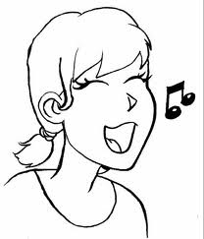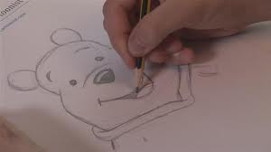

Sing Draw Write Read

