Teacher : Benzarti Hédia | English test N 1 Class: 6th form  2015-2016 | Primary school :  1st of June’sSchool Monastir
Name: ………………… | English test N 1 Class: 6th form  2015-2016 | Primary school :  1st of June’sSchool Monastir

Read the text

Hi! My name’s Sami .I’m Tunisian . I’m 11. I’m a pupil in a
primary school. This is the photo of my school.
It’s in Monastir . It’s big . My teachers are all
nice and friendly.
I have got two sisters and one brother .My phone number is 03876543.
alittle dag ; his name is rex.

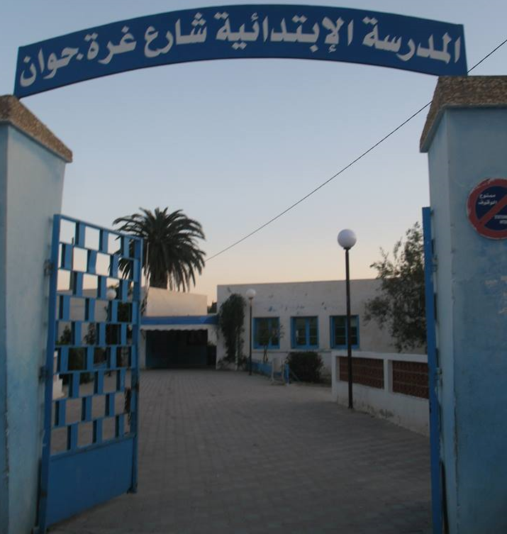

V Comprehension : (6 marks)
1)- Circle the right answer: . (3marks)

- Sami is twelve .
- The school is little .
- The teachers are good .

2)-Read the text and write (Yes ) or (No) . (1.5 marks)
a- This school is in Tunisia.
b- Sami has no brothers .
c- Sami is an English boy.

3)Complete the sentences with words from the text.(2.5marks)
Sami is from ………………He is a …..………. at a primary school .
His phone number is ………..He has got two ………and one …………. .
Language : ( 8 marks) :
1-)Write the missing family words. Follow the example(1.5mks)
1- I am her son; she is my mother.
2- I am his son; he is my .............................................. .
3- I am her brother; she is my .............................................. .
4- I am his grandson; he is my .............................................. .

2)- Circle the correct word : ( 2marks )
( This / These) are my friends Rami and Selem . They ( are / am)
ten and tweleve . Selma is from Gafsa . ( He / She ) is Tunisian .
(Her / His) phone number is : 22 4567 89 .
Complete with : (How / What / Where) : ( 1marks )
- …………… are you from?
- ……………is your phone number?
Read and draw the hands of the clock : ( 2marks )
It’s nine o’clock | It’s two o’clock | It’s seven fifteen | It’s eight thirty-five
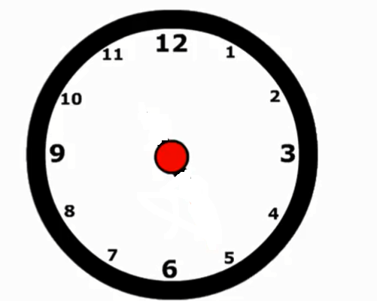

2) Correct the spelling mistakes.(1.5marks)
Her fone ................................... number is doble ............................. three, seven, four, nine, eigt ...................................

Writing : ( 6 marks)
Put in order the following sentences :

a /_ too - meet - Nice – to– you
… ………………………………………………………………………………………………
b / number- my- 07567843 - is - phone .
…………………………………………………………………………………………………

Write about youself :
My name’s………………….I’m11. I’m from……………………………and
I live in …………………….
This is my father. His name’s……..….……And this is my mother .
Her name’s……………..


