Name : ……………………
 Class : 6 ^{th} …...

- 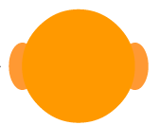After Listening, answer the questions  2) Write about you  My name’s………………….I’m11. I’m from……………………………and I live in …………………….  This is my father. His name’s…………..……And this is my …….. Her name’s……………..  3) Complete the crossword with the words for parts of your body  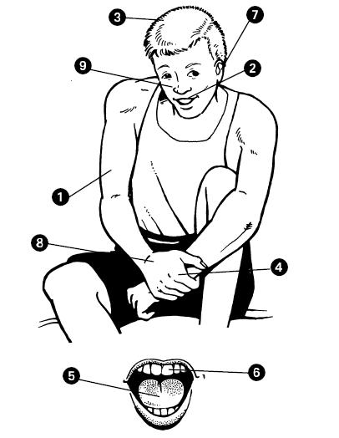  4) Write the numbers  Good luck | Mark  …/8  Mark  …/3  Mark  …/5  Mark  …/4  20
  Who is speaking ? | ( ) a boy  ( ) a girl
  What is his / her name ? | Make a sentence  ………………………………………….
  How old is he / she ? | Make a sentence  …………………………………………
  Where is he / she living ? | ( ) England  ( ) France  ( )Germany
  What is his / her father? | ( ) He is a baker  ( ) He is a teacher
  At school, his / her uniform is | ( ) green with a white tie  ( ) blue with a white shirt
  Who is Max ? | ( ) his / her brother  ( ) his / her dog
  What can he / she do ? | ( ) Play the guitar  ( ) Play the piano
  1A | R | 2M
   |  |  |  | 4F
   |  | 3H
   |  |  |  |  |  | 6T
   | 5T
   |  |  |  |  |  | 7E
   |  |  |  |  |  | 8H |  | 9N
  one | t…………….. | three | f…………….
  five | six | seven | e……………
  nine | t………………. | eleven | twelve

