Wonderful world
Unit ( 2 )
Mark the correct answer ( √ ):.
Yes No
1- They're giraffes. 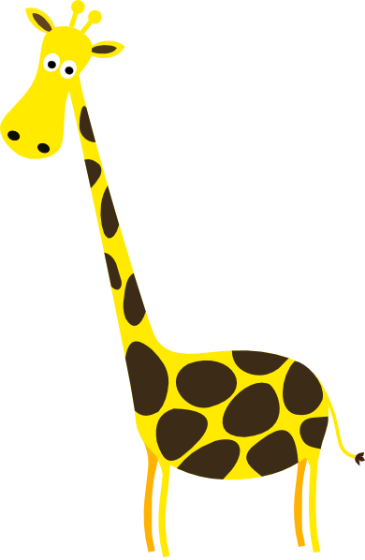
2- She isn't tall. 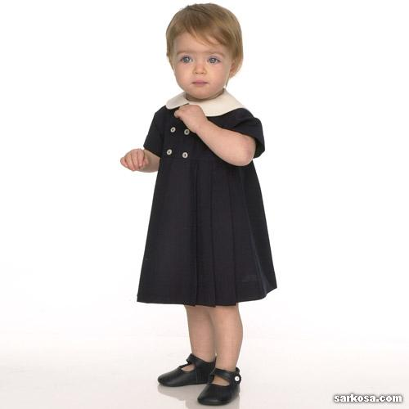
3- I'm a girl. 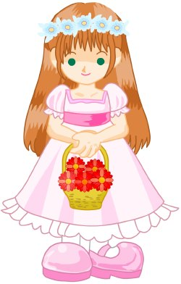
4- It's a robot. 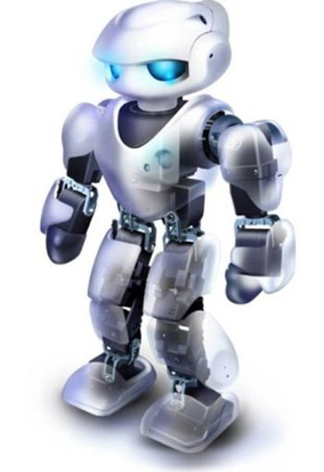
5- Six hats. 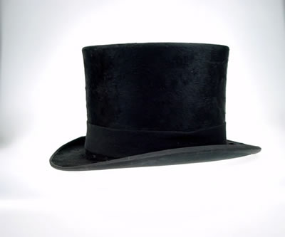
6- He isn't grandpa. 
7- She is happy. 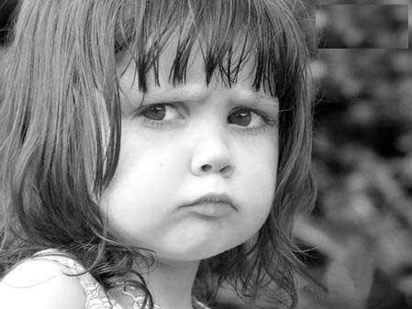
******************************
Re-arrange:.

1-boy – We – tall – 're .
…………………………………
2-is – The –short – baby .
…………………………………
3-a – It – robot – 's .
…………………………………
4-isn't – Dad –short .
…………………………………
5-you – Are – ten ?
…………………………………
6-are – Lions – big .
……………………………………
************************
Complete the words:.
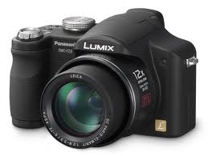 |  | 
Cam – ra | Gira – fe | Hap – y
 | 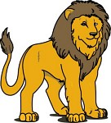 | 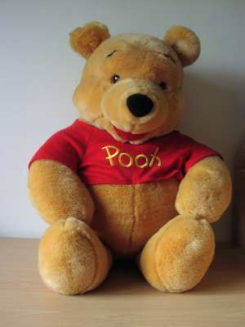
Pre – ent | Li - n | Te – dy be –r
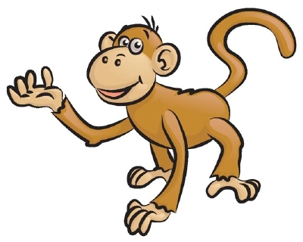 | 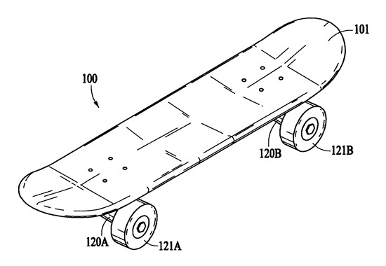 | 
Mon – ey | Sk – te boa – d | B – ll
 |  | 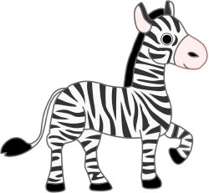
Ro – ot | Do – | Zeb – a

***************************
Underline the correct word(s) in brackets:

- She ( am – is – are ) a girl .
- ( Am – Is – Are ) you ten ?
- The baby ( am – is – are ) short .
- ( He – We – I ) am a boy .
- It's a ( camera – cameras – pictures ).
- It ( 'm not – isn't – aren't ) a skateboard .
- Are ( I – He – You ) short ?
- You ( 'm – 's – 're ) welcome .
- Happy birth ( day – month – week ) Maria .
10- A computer ( games – game – girl ) is great .
*************************

Look at the pictures and write the missing parts:.

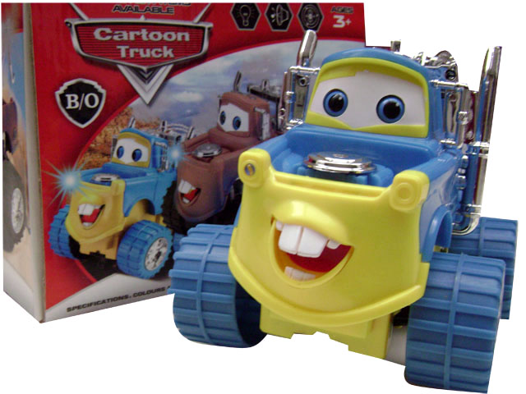 | 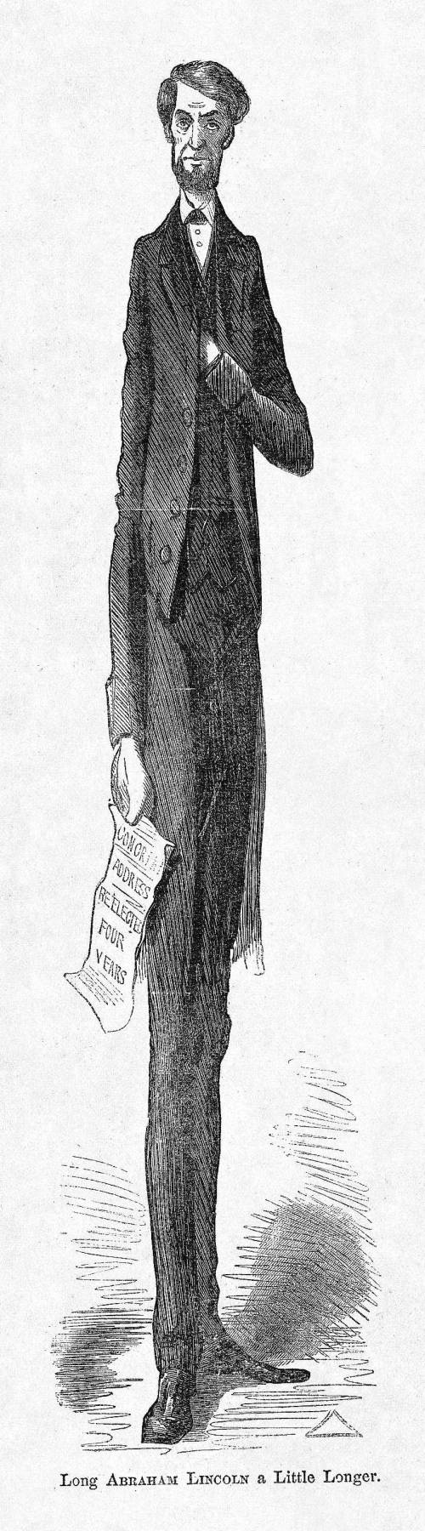
It's a ……………. | He …………short
………..it a teddy bear? | They're ………….
It's………camera | It's a ……………..
 | 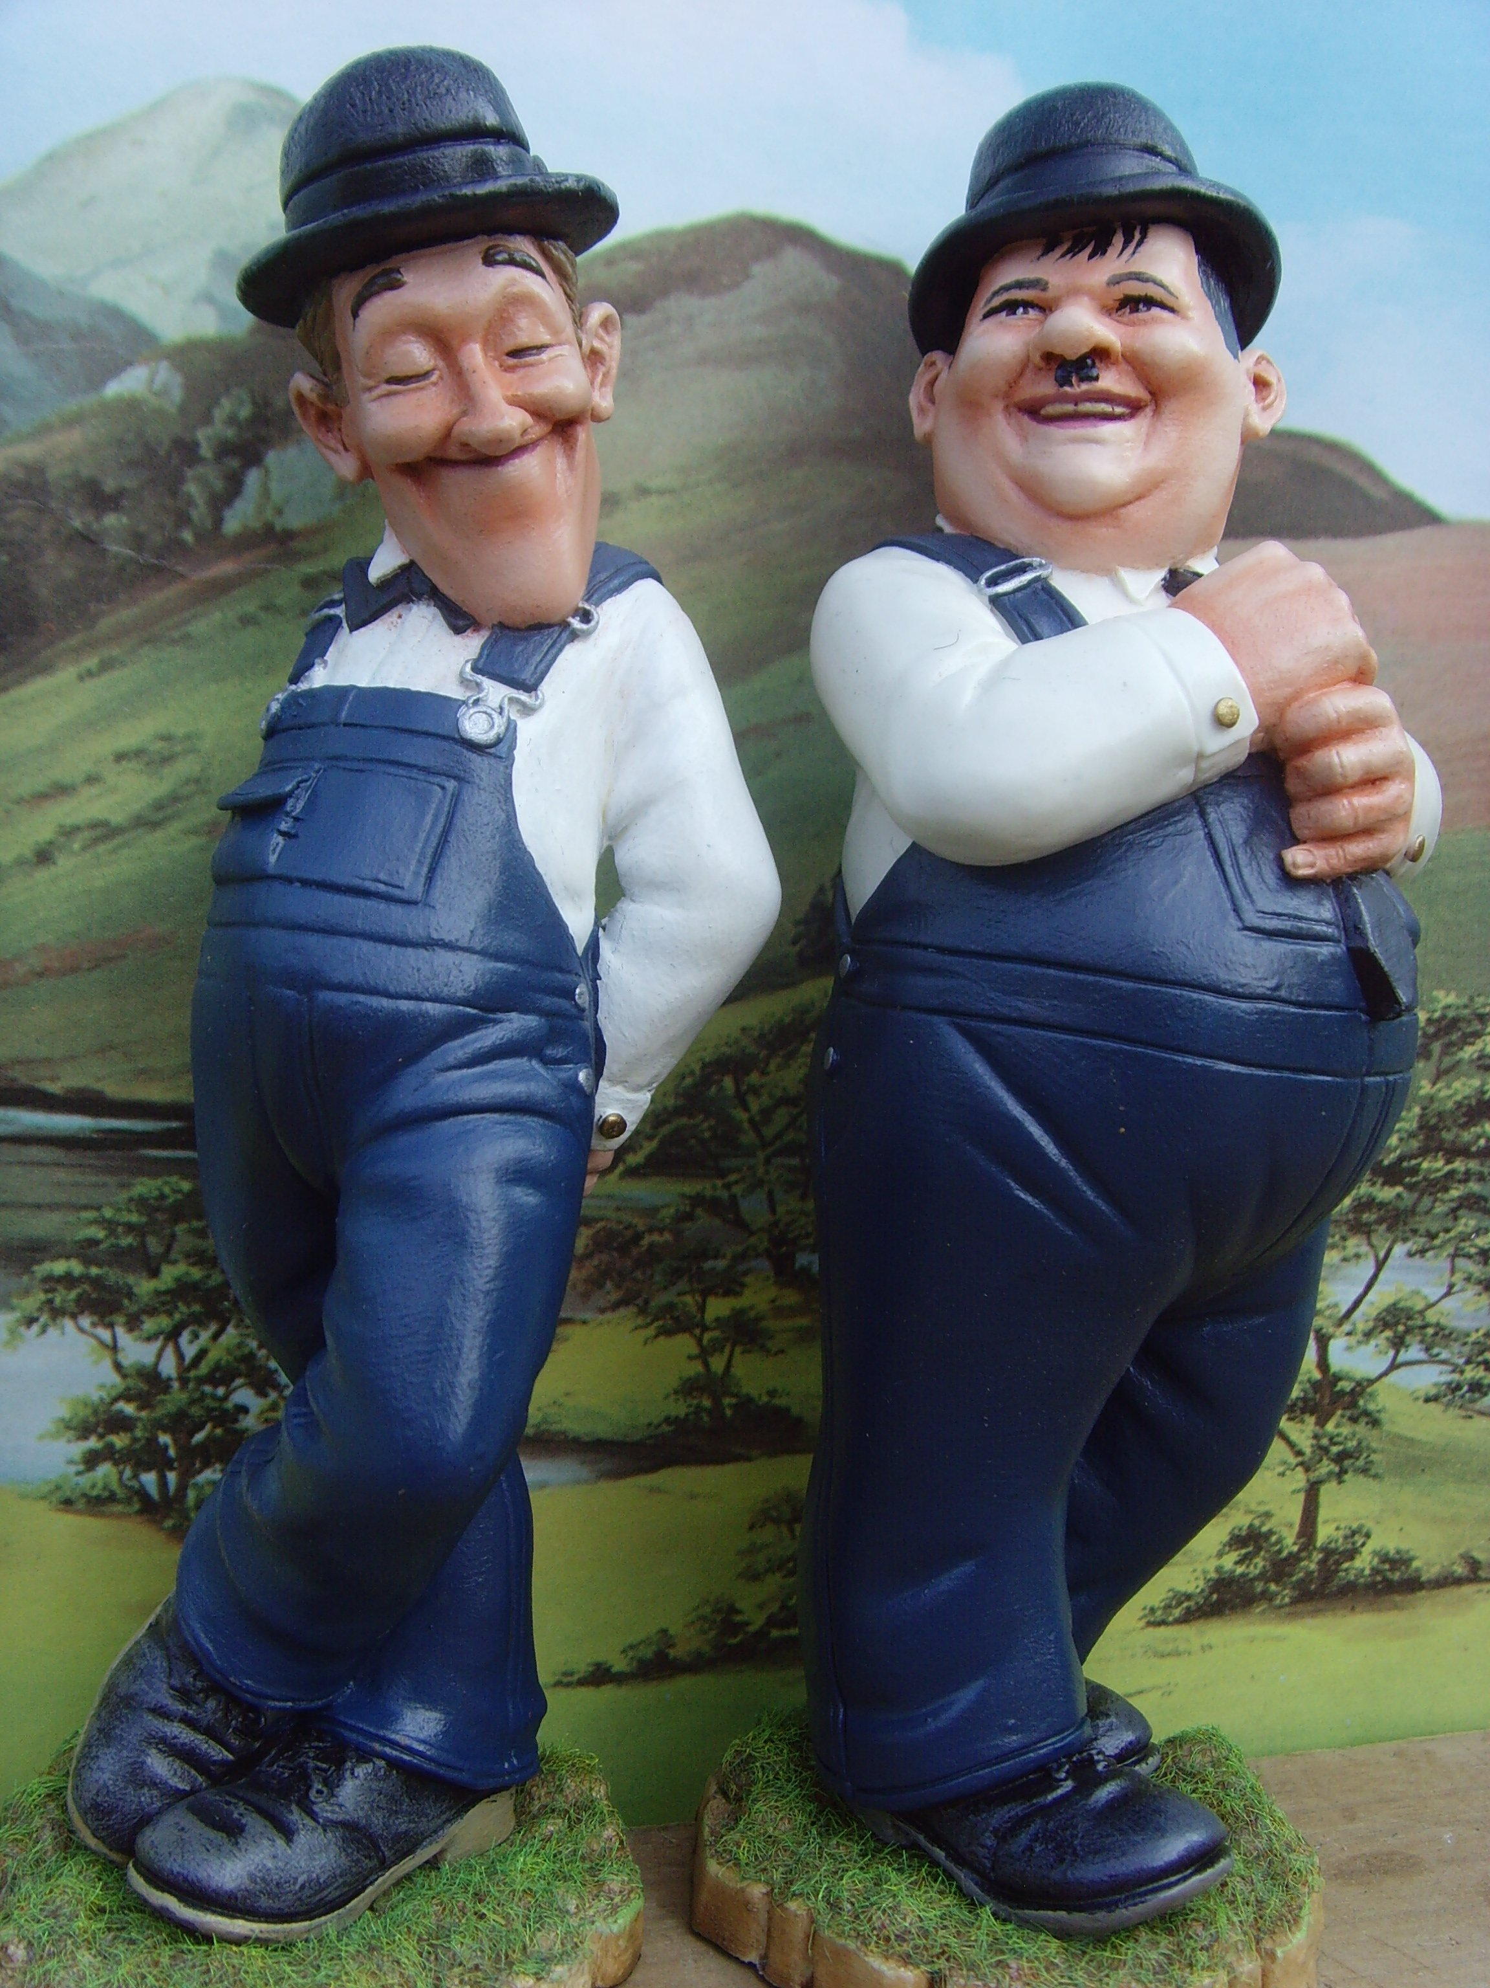
It's a …………… | They …………tall
GOOD LUCK

